Media Release

Teufen, May 13th, 2014

The Day when all Insects Disappear
Cinematic plea for more respect towards the “little giants”

If all insects were to disappear overnight, we human beings would be extinct by 2024. Still, we spend billions to keep our houses free of insects. But what benefits do insects have to offer? How do they enrich our lives? What does a fly have to do with chocolate? The animated short film „Little giants“ being released today is sticking up for our “6-legged partners”. Of all people, the film was produced by a businessman who is specialised in fighting insects, Hans-Dietrich Reckhaus.

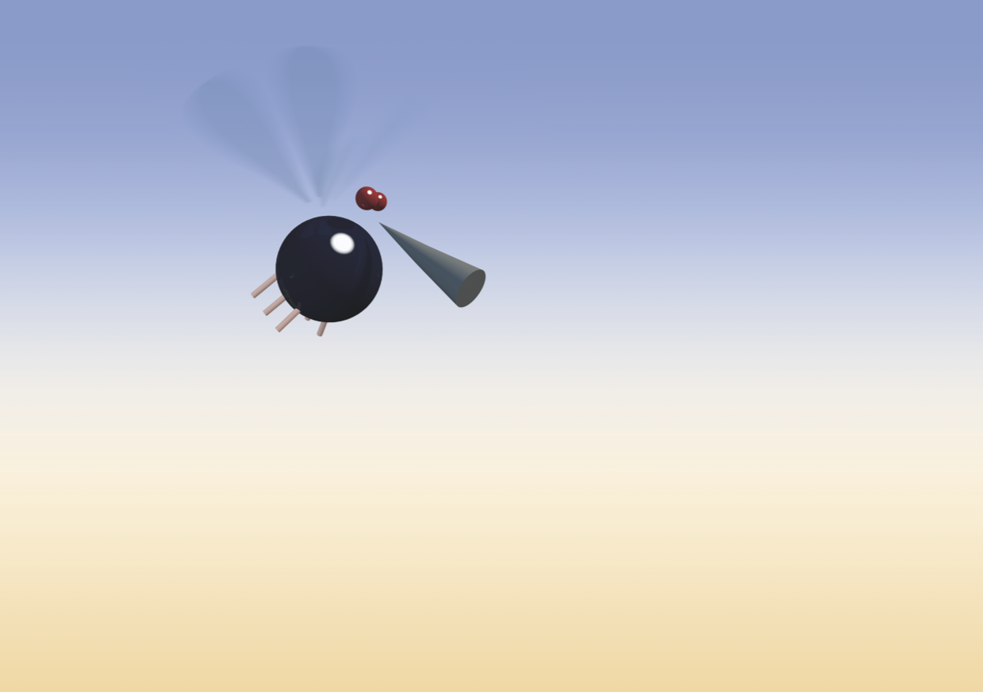 | Animated film „Little giants“  © Insect Respect  insect-respect.org/littlegiants

An animated film aiming to wake us up

“It is high time that these unrecognized heroes of nature are properly appreciated – and no other medium is better for this purpose than a film”, insists Hans-Dietrich Reckhaus, businessman and founder of Insect Respect. This is why Insect Respect is presenting the animated short film “Little giants” in time for the start of the insect season. With surprising aha-effects and creative imagery, the producers aim to sensitize the audience – especially children and adolescents – towards the value of insects.

The exterminator who became a saviour

Despite the fact that insects contribute to our quality of life in many ways, we consider insects, with very few exceptions like the busy bees, to be foes rather than partners. “Every year, we spend more than 5 billion dollars just to eradicate flies, mosquitoes and other insects from our homes.” says Hans-Dietrich Reckhaus. He should know: As a businessman, he earns his money with the production of insecticides. Instigated by the two concept artists, Frank and Patrik Riklin, he radically changed his business model and created the mark of quality Insect Respect (see below).

“Pests” who are actually beneficial

The numbers are impressive, but are hardly known: 75% of all plants rely on insects for their propagation. One third of our food and the majority of our clothing owe their existence to the work of insects. Moreover, without insects, the planet would be transformed into a huge pile of dung: The mere annual work performed by beetles feeding on dung is estimated by scientists to have a value of 20 billion dollars. Altogether, the benefits of insects cannot be appreciated highly enough: According to Edward Wilson, the most famous entomologist, human beings would not survive for more than 10 years without insects.

On behalf of Insect Respect, the cartoonist Simon Oberli created the animated film “Little giants” according to a script from the creative agency Alltag and with scientific advice from the biologist Stefan Liersch. The idea for the film was inspired from the “Saving flies” campaign by Frank and Patrik Riklin.

http://www.insect-respect.org/littlegiants

Short profile

Who is Insect Respect?

Insect Respect is the first mark of quality worldwide for econeutral insect control. For all insects that are killed by a biocide, Insect Respect creates species-appropriate compensation areas. In addition, Insect Respect invests in research and dialogue projects on the value of insects. The idea for Insect Respect was developed within the scope of the campaign “Saving flies” by the concept artists Frank and Patrik Riklin in collaboration with the entrepreneur Dr. Hans-Dietrich Reckhaus. His family-run company counts among the leading insecticide manufacturers on the European market.

Insect Respect on the Internet: www.insect-respect.org

Contact person for information and interviews

Dr. Hans-Dietrich Reckhaus

Telephone +41 (0)71 330 05 35
Email hd.reckhaus@reckhaus.com
Video data and images

The original files can be downloaded at the following address:

www.ftpland.ch

User name: little
Password: giants

Video data:

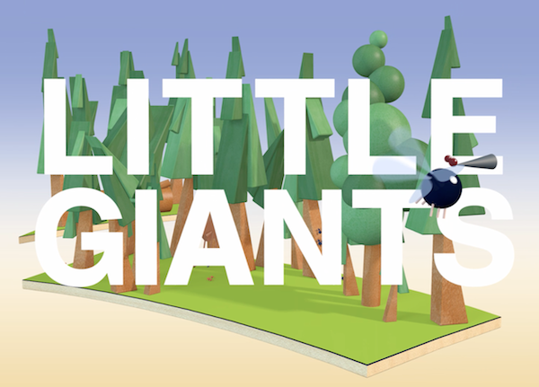  little_giants _movie_en.mp4 | Little giants:  Animated film on the value of insects  (available in German and English)

Images:

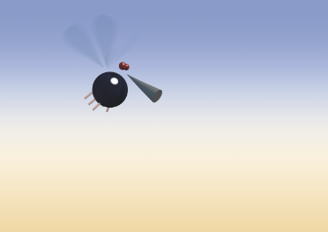  little_giants_fly.tif | The big world saviour:  the protagonist of the animated film
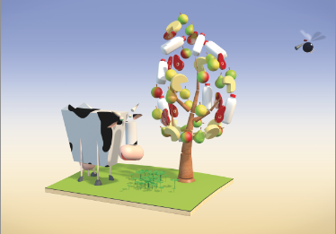  little_giants_nature.tif | Tiny creature, huge effect:  We all live from the work of insects

hans_dietrich_reckhaus_1.jpg | Respectful exterminator:  Businessman Hans-Dietrich Reckhaus
hans_dietrich_reckhaus_2.jpg
insect_respect_label.jpg | Insect Respect:  Mark of quality for econeutral protection against insects

